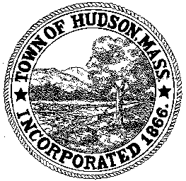

CONSERVATION COMMISSION
78 Main Street, Hudson, MA 01749
(978) 562-2020

Paul Byrne, Chairman W. Minot Wood, Vice Chairman David Esteves, Member

Terrence Joyce, Member Leif Longtine, Member Joseph Rodrigues, Member Al Tashian, Member

Meeting Minutes
April 15, 2010

- Preliminaries
  - Meeting opened at 7:00 PM
  - Roll Call: Paul Byrne, Minot Wood, Al Tashian, Daveid Esteves, Leif Longtine, Joe Rodrigues, Minot Wood

2.0 Hearings and Appointments
2.1 RDA HUD 392
Applicant: Scot Woodard
Location: 7 Ruthellen Road
Project Description: Remove part of the driveway and lower the grade 12”
Minot motioned to close the public hearing and issue a negative determination. Motion was seconded by Joe and carried 6-0

3.0 Meeting was adjourned at 7:30 PM

